This report examines the RTOS architecture and usage of Global Variables for the robotic car project.

**1. RTOS Architecture**

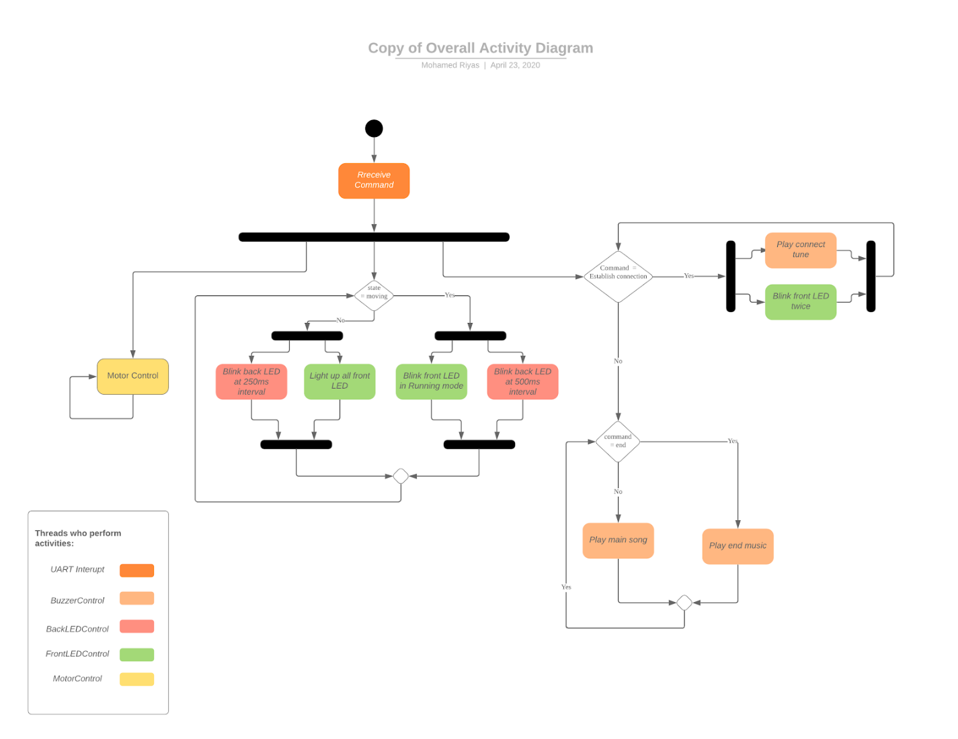A total of five threads consisting of four tasks and one interrupt, were created to execute the respective functions. The flow between these threads can be seen in the figure below.

**Figure 1: Overall activity diagram for the RTOS-based robotic car**

**1.1. Global variables**

The two global variables that were created and utilized, are as below:

volatile uint8_t data;

* Variable to contain the data received from the Bluetooth module
* Needs to be volatile for other threads to get the updated command from the app and do the right action accordingly

volatile int state;

* Variable to indicate the current state of the bot
* state = 0 when the bot is stationary & = 1 when the bot is moving
* Since state is being checked in multiple threads, it should be volatile to ensure that the data is updated whenever it is changed.

**1.2. Threads/Tasks**

The four tasks implemented in the project and their corresponding priority levels are as follows:

a) MotorControl (High Priority)

* Performs the necessary action with respect to the data received which includes changing the PWM signal accordingly to enable the robotic car to move in different directions and causing the front LED to blink twice upon the establishment of a Bluetooth connection
* Highest priority given to ensure that the bot response to the command is almost real time

b) FrontLEDControl (Low1)

* Controls the front green LEDs according to the state of the bot as highlighted below:
  + state = 0 (bot is stationary): Front LEDs are lighted up continuously
  + state = 1 (bot is moving): Front LEDs are in a Running Mode (1 LED at a time)

c) BackLEDControl (Low)

* Controls the rear red LEDs according to the state of the bot as highlighted below:
  + state = 0: Rear LEDs flash continuously at a rate of 250ms ON, 250ms OFF
  + state = 1: Rear LEDs flash continuously at a rate of 500ms ON, 500ms OFF

d) BuzzerControl (Normal)

* Plays notes of the respective music tune by changing the PWM signal accordingly
* Second highest in priority to ensure that music played is at the right pitch on the correct tempo

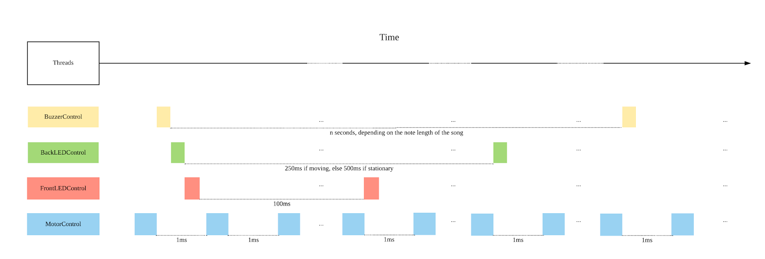The timing diagram of these threads is illustrated in the below diagram:

**Figure 2: Timing diagram of threads**

As seen in figure 2, the MotorControl thread runs every millisecond. Meanwhile, the BackLEDControl thread would toggle the LED every 250ms if the bot is stationary, or 500ms if the bot is moving while the FrontLEDControl thread “scrolls” the LED every 100ms if the bot is moving, or lights all of the LEDs up otherwise. Lastly, the BuzzerControl thread would change the PWM frequency of the buzzer with a variable period, depending on the length of the note.

**1.3. Usage of Mutex**

As explained in 1.2, both MotorControl and FrontLEDControl threads make use of the shared resource of the front green LEDs. MotorControl have to ensure that the green LEDs blink twice upon the establishment of a Bluetooth signal while FrontLEDControl have to ensure that the green LEDs are either lighted up or in a running order depending on whether the bot is moving. In order to ensure they don’t conflict, a mutex, ledMutex was created. This way, when one task is in possession of the mutex, the other would be unable to acquire it until it gets released from the first task.

**1.4. Usage of Interrupt**

UART2_IRQHandler acts as an UART2 interrupt on receive and reads from the UART register into the global variable data and sets the state of the bot either 1 or 0.

**2. Detailed Explanation of Code**

**2.1. Initialization**

On startup, we initialize our PWM, LED and UART through initPWM(), initLED()and initUART2(), and then initialize the kernel, create the threads as stated in section 1.2., and start the kernel.

The first thread to run is MotorControl since it has the highest priority. As no data packet has been received yet, it does nothing and gives up the CPU for 1ms using osDelay(1). This causes the next highest priority thread, BuzzerControl, to run which starts to play the respective notes of the main song tune. The call of osDelay() between successive notes enables  FrontLEDControl to run which turns on all the green LEDs since the global variable state is 0 as the bot is stationary. It then gives up CPU for 100ms and finally allows BackLEDControl to run which toggles the back red LEDs and gives up the CPU for 250ms.

**2.2. Upon Establishment of a Bluetooth Connection:**

On connect, the mobile app would send the data packet, 0x08, to the Bluetooth module. The ISR, UART2_IRQHandler, would hence get triggered and read the data packet into the global variable data.

When MotorControl runs, upon checking that the data packet received is 0x08, it would try to acquire the ledMutex to ensure that the front LEDs blink by first turning the LEDs OFF. After which, it would sleep for 1s by calling osDelay(1).

Next, BuzzerControl runs and upon checking that the data received is 0x08, it would play the connect tone, giving up the CPU after each note for the duration of the note, and setting the frequency of the note by setting the PWM frequency. After the end of the connect tone, it would once again start to play the main tune.

Meanwhile, after 1s, when motor control is ready to run again, it would turn the LED on, give up the CPU again for 1s. This toggling cycle would repeat for another time before changing the global variable data to 0x09 and releasing ledMutex.

During this process, when the code reaches FrontLEDControl, it would try to switch the LEDs on. However, it would be unable to do so as it is unable to acquire ledMutex, and it would enter a blocked state. It would only run and turn the LEDs ON after ledMutex has been released. Meanwhile, BackLEDControl would continue to ensure that the red LEDs blink at the correct rate.

**2.3. On Data Packet:**

The app sends a data packet when a respective button corresponding to an action that needs to be done, is pressed. The table below shows the corresponding packet that is sent.

|  |  |
| --- | --- |
| **Data packet** | **App action** |
| 0x01 | Play end music |
| 0x02 | Forward |
| 0x03 | Backward |
| 0x04 | Rotate Left |
| 0x05 | Rotate right |
| 0x06 | Curve Leftwards |
| 0x07 | Curve Rightwards |
| 0x08 | Signal to indicate connection has been established |
| 0x09 | Stop Moving |
| 0x10 - 0x6E | Sets the power level of the motor |
| 0xCD - 0xE6 | Sets the curvature radius of rotation |

As for directions commands, the app would send a single packet corresponding to the respective direction that we want the bot to move, when we press and continue to hold the respective button. Once the button is lifted up, the app would send a single stop packet. As such, the data 0x09 is not represented by any buttons and would be sent automatically whenever the buttons corresponding to the directions are released.

When the ‘Set Power’ button in the app is pressed, an integer value of 10 to 110 is sent, which corresponds to the speed at which we want the bot to move. This value is the nearest integer percentage of the speed slider bar + 10. The larger the integer value, the faster the bot would move. Likewise, an integer value between 205 - 230 would be sent if the curvature slider bar had been modified which corresponds to the angle at which we want the bot to curl. Similar to the speed cursor bar, a larger value represents a wider curvature angle and vice versa.

When UART2 interrupt is triggered, the data packet is read from the UART register and stored in the global variable data. It also sets the global variable state to 1 if the data packet corresponds to the bot moving (which is anything between 0x02 and 0x07).

When MotorControl runs, it would take action based on the data, and if it corresponds to a direction command, it sets the PWM duty cycle of the motor respectively, multiplied by the power and curvature that we have set accordingly.  If data is between 10 - 100, we know that it is a power packet, and we calculate and set the desired power variable in the task. When the task runs the next round 1ms later, the PWM duty rate would be then updated. Similarly, if data is above 200, we know that it is a curvature value, and set it, accordingly, which would update the PWM duty rate in the next iteration. At the end of each loop, the CPU is given up for 1ms in order to let other threads to run.

Thus, this allows for the BuzzerControl to run when it needs to change the notes of the song accordingly. When FrontLEDControl and BackLEDControl run, they would check the global variable state and flash the LEDs accordingly.

**2.4. Upon Reaching the End of the Maze**

Upon finishing the maze, the Stop button in the app (which is different from the data packet 0x09 which represents ‘Stop Moving’) needs to be pressed to indicate that the bot has finished the maze. This would send a data packet of 0x01. When the data being read is 0x01, the BuzzerControl thread will set its local variable, end, to 1. Thus, on all subsequent runs then after, upon checking end = 1, BuzzerControl would play the ending song tune instead of the earlier music tune.